Spreadsheet Methods B20028

Practical Examination

Duration: 2 hours

Instructions to candidates

- Attempt all tasks in order.

- Read the paper thoroughly before you attempt any of the tasks.

- Enter your name and examination number clearly on all printouts.

- Printing may be carried out, under supervision, after the time allowed for the examination but no alteration may be made to saved files.

- The use of calculators is strictly forbidden.

- Files can be saved on storage media provided by the exam supervisor at the end of the exam

- At the end of the examination all signed copies of exam papers and exam work (printouts and digital work) must be returned to the supervisor.

- All printing can be done at the end of the exam

Candidate Name: ______________________ Date: _________________

Tutor: Carol Ward

Peter Murphy runs a Computer Company that promotes small hardware devices at various shops throughout Ireland. Individual promoters are employed on a basic rate and an hourly rate but they can also be paid a bonus for the amount of days they have worked. You are required to set up a spreadsheet to calculate the wages and bonuses for the promoters.

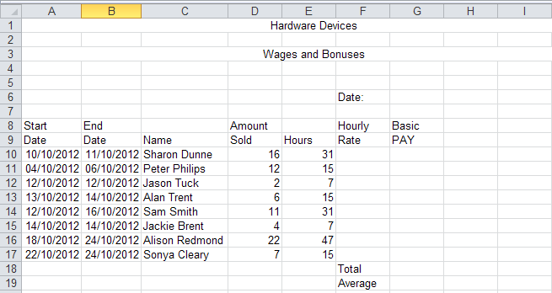

Figure 1

- Set up the spreadsheet and input the data as shown in Figure 1. Half a mark will be deleted for each mistake up to 2 marks (Creating 2 marks)

- Set all alignments as shown as and apply appropriate column widths. (Creating 1 mark)

- All monetary data should be displayed in the currency format with two decimal places. (Creating 1 mark)

- Format all dates as shown. Insert today’s date from the computer clock into the cell beside the heading Date: (Creating 1 mark)

- Use the If function to calculate the Hourly Rate based on the following information:
  - If the Hours are less than 15, then the Hourly Rate is 11 euro
  - If the Hours are greater than or equal to 15, then the Hourly Rate is 17 euro.
(Creating 2 marks)

- Calculate the Basic Pay per person as the Hours multiplied by the Hourly Rate.
(Creating 1 mark)

- Use the Sum function to calculate the total Basic Pay and display in the cell beside the heading Total. (Creating 1 mark)

- Use the Average function to calculate the average total basic pay and display in the cell beside the heading Average. (Creating 1 mark)

- Insert a new row above the label Date. Add a label called Name and type your name beside it (Edit 2 marks)

- Sort the entire spreadsheet in ascending order on the Hours Column. (Organise 2 Marks)

- Save the spreadsheet under the file name Device 1, for printing now or later.
(Save and Print ½ mark)

- (A) Produce a printout of the whole spreadsheet Device 1, excluding the main heading and showing Row and Column identifiers. (Save and Print 1 mark)

- (B) Produce a printout of the whole spreadsheet Device 1, showing all Formulae with the cell references and Row and Column identifiers. (Save and Print 1 mark)

- Delete the record of Sam Smith from the spreadsheet. (Edit 2 marks)

- Move the label Name from its current location and place it below the label Rate as shown. Delete the row above the label Date so there is one row remaining between the heading Wages and Bonuses and the label Date. (Edit 2 marks)

- Input the additional information as shown in BOLD print in Figure 2 below and move the side heading Date: and today’s date to their new positions. (Edit 2 marks)

Figure 2

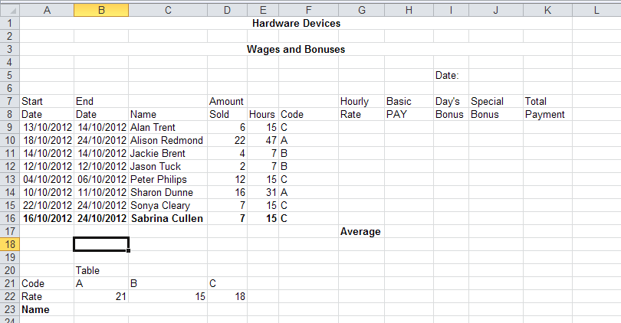

- Insert the additional record for Sabrina Cullen at the bottom of the list in the position shown. (Edit 1 mark)

- Use the IF function to insert the following into the Code column: if the Hours are greater than 15 the code is “A”, if the Hours are less than 15 the code is “B”, if the Hours are equal to 15 the code is “C”. (Creating 2 marks)

- (A) Delete the values in the column Hourly Rate (Edit 1 mark)
(B) Use the LOOKUP function to insert the Rate from the table into the column under the column heading Hourly Rate. (Creating 2 marks)

- Use the IF function to calculate the Days Bonus based on the following information:
  - If the end date is not equal to the start date, then a day’s bonus is paid at the rate of 4 Euro per day.
  - If the end date is equal to the start date, then no bonus is paid. (Creating 2 marks)

- Use the IF function to calculate the Special Bonus based on the following information:
  - If the amount sold is greater than 12 then 20 Euro special bonus is paid.
  - If the amount sold is greater than 6 then 10 Euro special bonus is paid.
  - Otherwise no special bonus is paid. (Creating 2 marks)

- (A) Calculate the Total Payment, for each promoter as the sum of Basic Pay, Days Bonus and Special Bonus. (Creating 1 mark)

(B) Use the SUM function to calculate the Totals for the columns Basic Pay, Days Bonus, Special Bonus as well as Total Payment and place the row beside the heading Total, under the appropriate columns. (Creating 1 mark)

(C) Use the Average function to calculate the Average for the columns Basic Pay, Days Bonus, Special Bonus and Total Payment and place the row beside the heading Average, under the appropriate columns. (Creating 1 mark)

- Sort the entire spreadsheet in ascending order on the Name Column. (Organise 2 Marks)

- Save the spreadsheet under the filename DEVICE2 for printing now or later
(Save and Print ½ mark)

- (A) Produce a printout, in landscape orientation, of the whole spreadsheet DEVICE2 showing Row and Column identifiers. (Save and Print 1 mark)

(B) Produce a printout, of the spreadsheet DEVICE2 showing all Formulae with Cell References with Row and Column identifiers. (Save and Print 1 mark)

- Produce a Bar Chart from the spreadsheet DEVICE 2, to show the total payment made to each promoter:

  - The total payment should be taken from the Total Payment column.

  - The bar chart should have the heading Promoters Pay and Bonuses.

  - The X Axis should have the promoters name under each bar and have the word Promoter as the X Label.

  - The Z Axis should show the payment and have the words Total Payment at the Z Axis Label. (Chart or Macro 8 marks)

- Save the chart on a separate sheet in your workbook and call it Chart.
(Chart or Macro 1 mark)

- Print the Chart. (Chart or Macro 1 mark)

